| Experiment No. 3 |
| --- |
| Implement midpoint Circle algorithm. |
| Name: KRITHIK DEVENDRA PANDEY |
| Roll Number: 35 |
| Date of Performance: |
| Date of Submission: |

**Experiment No. 3**

**Aim**: To implement midpoint circle algorithm.

**Objective:**

Draw a circle using mid-point circle drawing algorithm by determining the points needed for

rasterizing a circle. The mid-point algorithm to calculate all the perimeter points of the circle

in the first octant and then print them along with their mirror points in the other octants.

**Theory:**

The shape of the circle is similar in each quadrant. We can generate the points in one section

and the points in other sections can be obtained by considering the symmetry about x-axis

and y-axis.

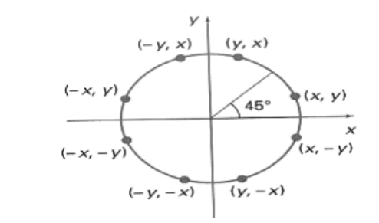

The equation of circle with center at origin is x 2 + y 2 = r 2

Let the circle function is f circle (x, y) -

• is &lt; 0, if (x, y) is inside circle boundary,

• is = 0, if (x, y) is on circle boundary,

• is &gt; 0, if (x, y) is outside circle boundary.

Consider the pixel at (xk, yk) is plotted,

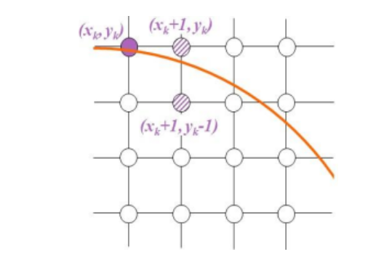

Now the next pixel along the circumference of the circle will be either (xk + 1, yk) or (xk + 1,

yk – 1) whichever is closer the circle boundary.

Let the decision parameter pk is equal to the circle function evaluate at the mid-point between

two pixels.

If pk &lt; 0, the midpoint is inside the circle and the pixel at yk is closer to the circle boundary.

Otherwise, the midpoint is outside or on the circle boundary and the pixel at yk – 1 is closer

to the circle boundary.

**Algorithm –** The Midpoint Circle Algorithm is a simple and efficient method for drawing a circle on a pixel grid in computer graphics. It uses the concept of the "midpoint" to determine which pixels should be part of the circle. Here is the step-by-step derivation of the Midpoint Circle Algorithm:

**Assumptions:**

1. You have a grid of pixels, and each pixel is identified by its coordinates (x, y), where (0,0) is the center of the grid.

**Algorithm:**

1. Start with the initial point at (x, y) = (0, r), where r is the radius of the circle.

2. Calculate the initial decision parameter: P = 5/4 - r (i.e., P0 = 5/4 - r).

3. Initialize x = 0 and y = r.

4. At each step, plot the points (x, y), (-x, y), (x, -y), and (-x, -y) to take advantage of the circle's symmetry.

5. Compute the next decision parameter Pk for the next pixel position (xk+1, yk) as follows:

- If Pk < 0, choose the pixel to the right: xk+1 = xk + 1 and Pk+1 = Pk + 2*xk + 3.

- If Pk ≥ 0, choose the pixel to the lower-right: xk+1 = xk + 1 and yk+1 = yk - 1, and Pk+1 = Pk + 2*xk - 2*yk + 5.

6. Repeat steps 4 and 5 until x is greater than or equal to y. At this point, you've completed one-eighth of the circle.

7. For each point plotted, reflect it in all eight octants to complete the full circle.

Here's a more detailed explanation:The algorithm starts at the point (0, r), which is chosen because it's on the circle's perimeter, and it's one of the points that minimizes the error when calculating the midpoint. The decision parameter P is initialized as P0 = 5/4 - r.

The algorithm then proceeds by incrementing x and decrementing y while repeatedly calculating the next decision parameter Pk. The choice of the next pixel depends on whether Pk is less than 0 or greater than/equal to 0.

The algorithm continues until x is greater than or equal to y. At this point, one-eighth of the circle is drawn, and the other seven eighths can be generated by reflecting the points in each octant.

The Midpoint Circle Algorithm is efficient because it minimizes the number of calculations and operations needed to draw the circle, making it suitable for use in real-time graphics and situations where performance is important.

**Program –**

#include<stdio.h>

#include<conio.h>

#include<graphics.h>

void pixel(int x, int y, int xc, int yc)

{

putpixel(x+xc,y+yc,BLUE);

putpixel(x+xc,-y+yc,BLUE);

putpixel(-x+xc,-y+yc,BLUE);

putpixel(-x+xc,y+yc,BLUE);

putpixel(y+xc,x+yc,BLUE);

putpixel(y+xc,-x+yc,BLUE);

putpixel(-y+xc,x+yc,BLUE);

putpixel(-y+xc,-x+yc,BLUE);

}

main()

{

int gd=DETECT,gm=0,r,xc,yc,x,y;

float p;

//detectgraph(&gd,&gm);

initgraph(&gd,&gm,"C:\\TurboC3\\BGI");

printf("\nEnter the radius of the circle:");

scanf("%d",&r);

printf("\nEnter the center of the circle:");

scanf("%d %d",&xc,&yc);

y=r;

x=0;

p=(5/4)-r;

while(x<y)

{

if(p<0)

{

x=x+1;

y=y;

p=p+2*x+3;

}

else

{

x=x+1;

y=y-1;

p=p+2*x-2*y+5;

}

pixel(x,y,xc,yc);

}

getch();

closegraph();

return 0;

}

**Output –**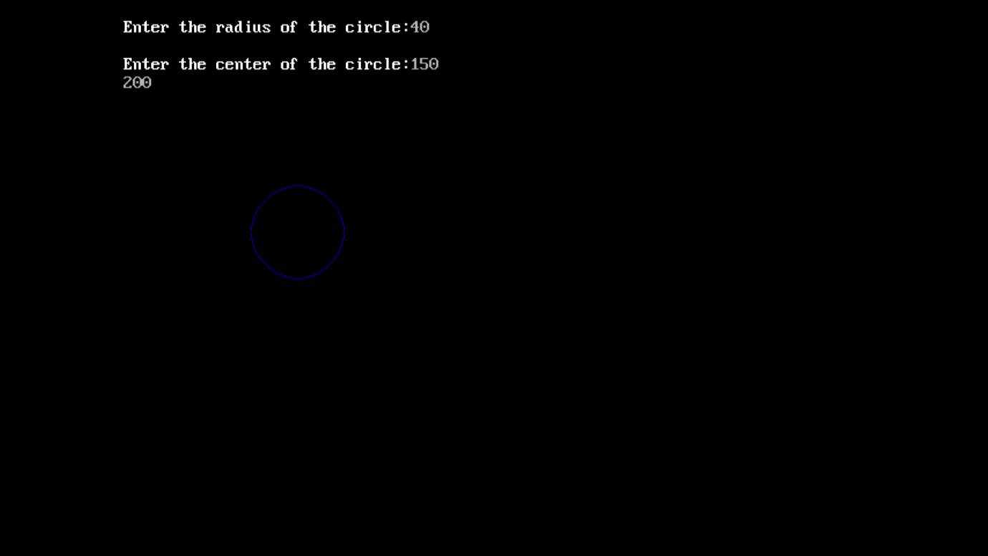

**Conclusion:**

The Midpoint Circle Algorithm is a widely used method for drawing circles in computer graphics. It differs from line drawing algorithms in its approach, specifically tailored to circles. Here's a brief comment on the Midpoint Circle Algorithm and a comparison with line drawing algorithms, along with a note on the process and time taken:The Midpoint Circle Algorithm is a fundamental tool in computer graphics, allowing for efficient and precise circle drawing. Unlike line drawing algorithms, it considers the symmetry of circles, optimizing the drawing process.It calculates points on the circle by incrementally moving along the circumference and adjusting the decision parameter.By exploiting symmetry, it reduces computational load compared to line drawing, which needs to account for various angles and slopes.The algorithm proceeds by iteratively determining points at each octant and mirroring them to complete the circle.It is highly time-efficient, with a complexity of O(n) for drawing a circle, where 'n' represents the radius.